2019-nCOV TRIAGE PROTOCOL

Is this a routine appointment or are you unwell today?
UNWELL
Any: fever, sore throat, cough, shortness of breath or other respiratory infection signs, including mild symptoms
ROUTINE
No fever, no sore throat, no cough, no shortness of breath or other respiratory infection signs, including mild symptoms

Have you travelled recently OR had contact with a confirmed or suspected case of coronavirus OR believe you may have been in infected?
Have you travelled recently OR had contact with a confirmed or suspected case of coronavirus OR believe you may have been in infected?

YES
Transfer call to nurse
YES
Transfer call to nurse
NO
NO

Appointment and infection control principles as usual
Appointment and infection control principles as usual

Pt wishes for advice
Coronavirus Hotline:
1800 020 080
OR
Public Health:
1300 066 055
OR
Local Hospital:
Blacktown - 9881 8000
Document in Patient File
Document on COVID Register

Pt wishes to be examined by a health professional
Local Hospital Blacktown - 9881 8000
Document in Patient File
Document on Register
Only those who meet the following criteria are eligible for testing:
International travel in the 14 days prior to onset of illness OR close or casual contact in the 14 days prior to illness with a confirmed case
AND fever OR acute respiratory infection
(+Pneumonia with no other cause identified or pneumonia in a healthcare worker)

Telehealth Consultation - REGULAR PATIENTS ONLY
MUST MEET CRITERIA AS DEFINED BY MEDICARE
Book Telehealth Consult – Ensure patient is waiting by the phone for at least 30 min before and after apt time and advise the call may come up as a restricted number (they must answer phone)
Document everything in file including symptoms/exposure and criteria met
If patient meets criteria for pathology testing:
Document on COVID Register
Fax Referral to DHM Blacktown
Notify Pt referral faxed
Pt to ring DHM to arrange apt and advise us of apt date
Pt to ring us 48hrs after swab done to check results back and book follow-up telehealth consult for results

Current as of 10/03/2020

COVID-19 Telehealth Consultation Criteria:

Pregnant, aged 70+, aged 50+ AND of ATSI descent, a parent of a child under 12months, a person who is immunocompromised or being treated for a chronic condition.

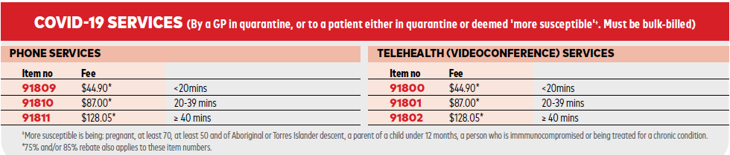

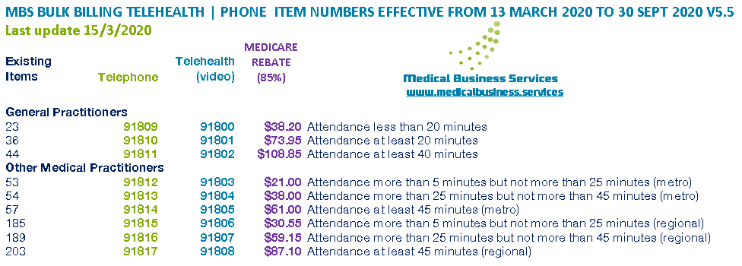

http://www.mbsonline.gov.au/internet/mbsonline/publishing.nsf/Content/news-2020-03-01-latest-news-March

http://www.mbsonline.gov.au/internet/mbsonline/publishing.nsf/Content/Factsheet-Current

https://www.medicalbusiness.services/mbs-telehealth-items-march-2020?fbclid=IwAR0Go32r1F_yswIee8o5HOCp3TWNoIRdezWioMGC8dfBwSx-JsgZ1fl7bVs
COVID-19 Testing Criteria:

https://www1.racgp.org.au/newsgp/professional/chief-medical-officer-update-on-coronavirus-testin
The guidelines have been endorsed by the Australian Health Protection Principal Committee and recommend testing only where a patient meets both the current epidemiological and clinical criteria for testing.
The epidemiological criteria include:
- international travel in the 14 days before illness onset
OR
- close or casual contact in the 14 days before illness onset with a confirmed case of COVID-19 (this needs to be interpreted sensibly; we do not have sufficient testing kits to test everyone who attends the same large concert as a person with COVID-19).

The clinical criteria include:
- fever
OR
- acute respiratory infection (eg shortness of breath, cough, sore throat) with or without fever.

Please note that if the patient has bilateral severe community-acquired pneumonia and no other cause is identified, with or without recent international travel, they are classified as a suspect case.
If the patient has moderate or severe community-acquired pneumonia (hospitalised) and is a healthcare worker, with or without international travel, they are classified as a suspect case.

