Step 1: COLLECTING YOUR EXTRACT
An extract is like a snapshot of your patient database at a set point in time.
To collect an extract click on the Collect button. Note: Depending on the size of your database this can take quite a while. Large practices may choose to do the collect overnight. “
When complete this is known as an “extract” and you only do a ‘Collect’ every once in a while (maybe monthly) as you are working on the one extract. Once improvements are made you do another Collect to verify your improvements.
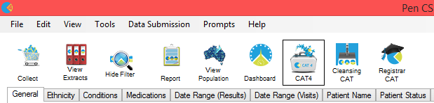
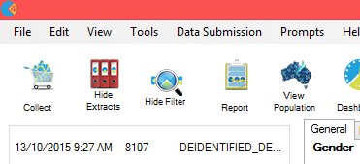
The next time you open PCS Clinical Audit you will click on the View Extracts button and then click once on the most recent extract.

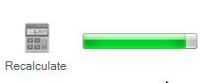
Step 2: APPLYING FILTERS TO YOUR EXTRACT
Once the ‘collect’ is complete you can then choose your desired ‘filters’ to further define what you want to look at eg. all ‘active’ patients. Once filters are selected click on Recalculate and wait until the green bar fills which signifies filtering is complete.
FILTERS
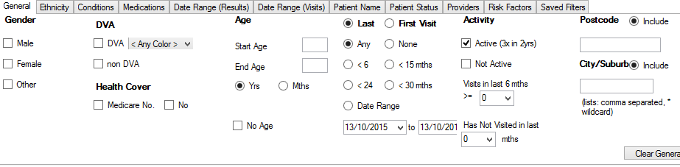
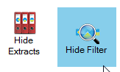
You could then click on Hide Filters and Hide Extracts to maximise your screen space as you analyse your selected patient population data.

Step 3: ANALYSING YOUR EXTRACT
Database Cleansing – where to start:
- Patients with no allergy status recorded
- Duplicate patients
- Patients with no gender
- Patients with no date of birth
- Patients with no height/weight status recorded
- Patients with no smoking status recorded
- Patients with incorrect diabetes coding

If you wanted to look at patients with no allergy status recorded select the Allergies tab.
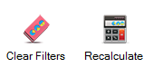
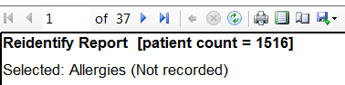
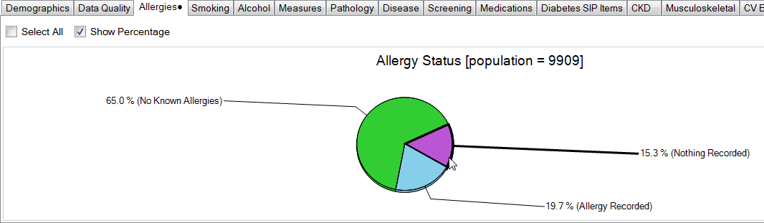
Click to highlight the wedge of the pie chart you are interested in viewing eg. Nothing Recorded.
Double-click on the wedge to view (or click Export) to view a list of patient names. You can then export this into an excel spreadsheet if required by selecting the floppy disk icon.

Tip: Always remember to Clear Filters to ensure you are looking at the required sub-set of data.

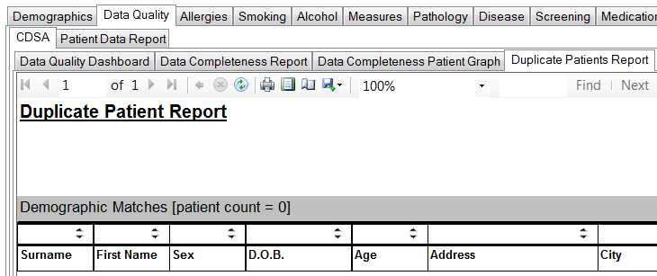
Exercise:
Search for duplicate patient records:

- Collect an extract.
- Select Data Quality tab.
- Select Duplicate Patients Report tab.
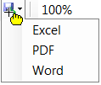
- Export this report to a spreadsheet.
- Go back into your clinical software and go through the spreadsheet and check patient records, merge duplicates if appropriate.

